CRIMINAL LAW PAPER · ISLAMABAD HIGH COURT · CIVIL JUDGE-CUM-MAGISTRATE EXAMINATION 2026
Topic 1 · Pakistan Penal Code — General Principles
Elements of crime · application of the Code · general explanations (good faith, harbour, wrongful gain and loss, dishonestly, fraudulently) · joint liability (ss. 34–38, 149) · punishments (ss. 53–75) · general exceptions including insanity, infancy, intoxication, necessity, consent, compulsion and private defence (ss. 76–106) · abetment (ss. 107–120) · criminal conspiracy (ss. 120A–120B) · attempt (s. 511)
Knowledge Base — every concept in simple words, with rationale, cases, illustrations and maxims

Prepared for: Ihtisham Ul Haq (Roll No. 999)
Paper: Criminal Law (100 marks, 3 hours) — Pakistan Penal Code 1860, Code of Criminal Procedure 1898, Hudood Ordinances
This volume: Topic 1 of 4 — PPC: general principles
Companion volumes: Topic 2 — PPC: specific offences (Qisas and Diyat, sexual offences, property offences, defamation) · Topic 3 — Code of Criminal Procedure · Topic 4 — Hudood Ordinances
Text of the law used: Official text of the Pakistan Penal Code (pakistancode.gov.pk), with amendments up to the Criminal Laws (Amendment) Act 2025

Contents
How to use this knowledge base 4
What Topic 1 covers 4
How the exam asks this topic 4
Chapter 1 · What is a crime? 5
1.1 Meaning 5
1.2 The two elements — actus reus and mens rea (LHC 2020) 5
1.3 Stages of a crime 6
1.4 Crime and civil wrong 6
Chapter 2 · Application of the Code (ss. 1 to 5) 8
Chapter 3 · General explanations (ss. 6 to 52A) 9
3.1 Why the definitions matter 9
3.2 The key definitions 9
3.3 Good faith — s. 52 (KPHC 2026) 10
3.4 Harbour — s. 52A (KPHC 2026) 10
Chapter 4 · Joint liability (ss. 34 to 38 and 149) 12
4.1 Common intention — s. 34 12
4.2 Sections 35 to 38 12
4.3 Common object — s. 149 12
Chapter 5 · Punishments (ss. 53 to 75) 14
5.1 The ten kinds of punishment — s. 53 14
5.2 Commutation — ss. 54, 55 14
5.3 Fine — ss. 63 to 70 14
5.4 Several offences — ss. 71, 72 15
5.5 Solitary confinement — ss. 73, 74 (LHC 2020) 15
5.6 Enhanced punishment for repeat offenders — s. 75 (LHC 2020) 15
5.7 Sentencing — aggravating and mitigating circumstances (SHC 2022) 16
Chapter 6 · General exceptions (ss. 76 to 106) 17
6.1 Burden of proof 17
6.2 Excusable and justifiable acts 17
6.3 Mistake of fact — ss. 76 and 79 18
6.4 Judicial acts — ss. 77, 78 18
6.5 Accident — s. 80 18
6.6 Necessity — s. 81 18
6.7 Infancy — ss. 82, 83 (LHC 2023) 19
6.8 Insanity — s. 84 (KPHC 2026 essay) 19
6.9 Intoxication — ss. 85, 86 20
6.10 Consent — ss. 87 to 92 21
6.11 Compulsion by threats — s. 94 21
6.12 Trifles — s. 95 22
Chapter 7 · The right of private defence (ss. 96 to 106) — LHC 2020 23
7.1 Basis 23
7.2 Scope — ss. 96 to 98 23
7.3 Restrictions — s. 99 (acts against which there is no right) 23
7.4 When the right of private defence of the body extends to causing death — s. 100 24
7.5 Commencement and continuance — body (s. 102) 24
7.6 When the right of private defence of property extends to causing death — s. 103 25
7.7 Commencement and continuance — property (s. 105) 25
7.8 Risk to an innocent person — s. 106 25
7.9 Principles from the case law 25
Chapter 8 · Abetment (ss. 107 to 120) — KPHC 2026 26
8.1 Abetment of a thing — s. 107 26
8.2 Abettor — s. 108 26
8.3 Punishment of abetment — the scheme 27
8.4 Abetment and common intention 27
Chapter 9 · Criminal conspiracy (ss. 120A, 120B) 29
9.1 Definition — s. 120A 29
9.2 Punishment — s. 120B 29
9.3 Conspiracy and abetment by conspiracy 29
Chapter 10 · Attempt (s. 511) 30
10.1 The section 30
10.2 Ingredients 30
10.3 Tests to distinguish preparation from attempt 30
Chapter 11 · Maxims and last-night revision 31
11.1 Maxims 31
11.2 The 30 points of Topic 1 32
zzTOCENDzz

How to use this knowledge base

What Topic 1 covers
- The idea of a crime — actus reus and mens rea; strict liability; stages of a crime.
- Application of the Code — territorial and extra-territorial (ss. 1–5).
- General explanations — the definitions that run through the Code (ss. 6–52A), especially good faith and harbour (KPHC 2026).
- Joint liability — common intention (s. 34), common object (s. 149), and ss. 35–38.
- Punishments — the ten kinds (s. 53), commutation, fine, solitary confinement and enhanced punishment for repeat offenders (s. 75).
- General exceptions (ss. 76–106) — mistake, judicial acts, accident, necessity, infancy, insanity, intoxication, consent, compulsion, trifles, and the right of private defence.
- Abetment (ss. 107–120), criminal conspiracy (ss. 120A–120B) and attempt (s. 511).
ISLAMABAD-SPECIFIC LAW · Pakistani features you must not miss
- Age of criminal responsibility raised in 2016: nothing is an offence by a child under ten (s. 82); a child above ten and under fourteen is protected if of immature understanding (s. 83) (Act X of 2016). Older books still say seven and twelve.
- Punishments start with qisas, diyat, arsh, daman and ta'zir (s. 53, as substituted by Act II of 1997).
- Imprisonment for life = twenty-five years for calculating fractions (s. 57).
- A death sentence for qatl cannot be commuted without the consent of the heirs of the victim (s. 54 proviso).
- Section 100 (private defence extending to death) has six clauses in Pakistan — there is no acid-attack clause as in India.
- Juvenile Justice System Act 2018 governs the trial of persons under 18 (Topic 3).

How the exam asks this topic
Paper | What it asked
KP High Court, Criminal Law, 2026 | Define good faith and harbour with examples; an essay on the defence of insanity in the light of superior-court cases; abetment, its forms, abetment of an offence punishable with death or life imprisonment if the offence is not committed, and if an act causing harm is done
LHC Civil Judge, Criminal Law, 2023 | Consequences of a criminal act by a child under seven (now ten); ikrah-e-tam and ikrah-e-naqis; wrongful gain and wrongful loss
LHC Civil Judge, Criminal Law, 2020 | Actus reus and mens rea; solitary confinement; wrongful gain and loss; enhanced sentence for previous convicts and whether s. 75 applies to CNSA cases; acts against which no right of private defence; when private defence extends to death; commencement and continuance of private defence of body and property
Sindh High Court, 2022 | Mitigating circumstances; conviction and sentence

Chapter 1 · What is a crime?

1.1 Meaning
A crime (offence) is an act or omission which the law forbids and punishes in the name of the State. The PPC defines "offence" as "a thing made punishable by this Code" (s. 40). Unlike a civil wrong, a crime is a wrong against society: the State prosecutes, and the remedy is punishment (though Pakistani law also gives the victim compensation — diyat, arsh, daman; CrPC ss. 544A, 545).

1.2 The two elements — actus reus and mens rea (LHC 2020)
LEGAL MAXIM · Actus non facit reum nisi mens sit rea
"An act does not make a man guilty unless his mind is also guilty." A crime normally needs (1) a guilty act (actus reus) and (2) a guilty mind (mens rea), which must coincide.

Actus reus is the physical element: a voluntary act or illegal omission (ss. 32–33, 36), in the circumstances and with the consequences forbidden by law. "Act" includes a series of acts; "omission" a series of omissions (s. 33); an illegal omission is an act (s. 32). Example: a jailor who starves a prisoner commits qatl by omission (duty to feed).
Mens rea is the mental element. The PPC does not use the phrase but writes it into each definition through words such as intentionally, voluntarily (s. 39 — intending, knowing, or having reason to believe the result likely), knowingly, dishonestly (s. 24), fraudulently (s. 25), rashly or negligently, reason to believe (s. 26), malignantly.
Degree of mind | Meaning and example
Intention | Desiring the result as the aim of the act — A shoots Z in order to kill him (qatl-i-amd, s. 300)
Knowledge | Awareness that the result will very probably follow — A sets fire to an occupied house to collect insurance
Recklessness / rashness | Consciously running an unjustified risk — driving at 120 km/h through a bazaar (s. 320)
Negligence | Failing to take the care a reasonable person would take — a surgeon leaves a swab inside a patient (s. 337H)

CASE STUDY · R v. Prince (1875) and Sweet v. Parsley (1970)
Prince: a man took a girl under 16 out of her father's possession honestly believing she was 18; convicted — the offence (abduction) imposed liability as to age. Sweet v. Parsley: the House of Lords held that mens rea is presumed to be required unless the statute clearly excludes it. These cases explain strict liability — in public-welfare offences (adulteration, weights and measures, narcotics possession under the CNSA once possession is proved) the prosecution need not prove a guilty mind.

1.3 Stages of a crime
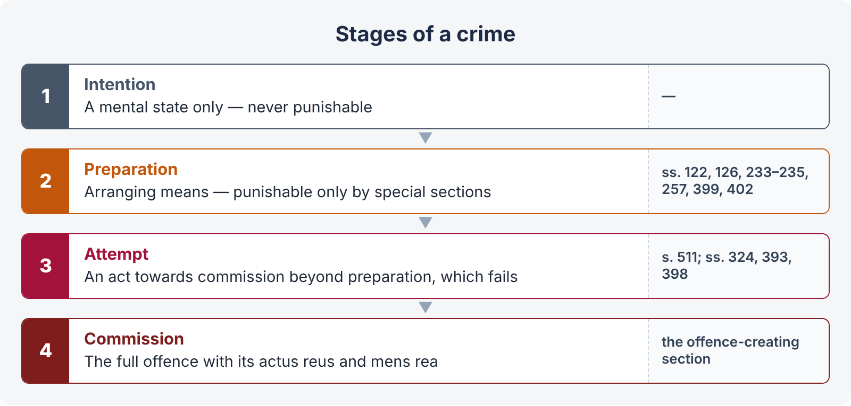
Figure 1 · The four stages of a crime
- Intention — not punishable; the law does not punish thoughts.
- Preparation — generally not punishable, because it is hard to prove that the preparer would have gone on. Exceptions: preparation to wage war against Pakistan (s. 122), to commit depredation on a friendly State (s. 126), making or possessing instruments for counterfeiting coin or stamps (ss. 233–235, 257), preparation to commit dacoity (s. 399), assembling for dacoity (s. 402).
- Attempt — punishable (s. 511 and specific sections such as ss. 307 (now s. 324), 393, 398).
- Commission — the full offence.

1.4 Crime and civil wrong
Point | Crime | Civil wrong (tort, breach of contract)
Nature | Wrong against society | Wrong against an individual
Who proceeds | The State (prosecution), or complainant | The injured party (plaintiff)
Object | Punishment, deterrence, reform | Compensation, restoration
Standard of proof | Beyond reasonable doubt | Balance of probabilities
Compromise | Only compoundable offences (CrPC s. 345; PPC s. 338E) | Always possible
Court | Criminal court (Magistrate, Sessions) | Civil court

LEGAL MAXIM · Accused is the favourite child of the law (LHC 2020)
The accused is presumed innocent until proved guilty; the prosecution must prove its case beyond reasonable doubt; the benefit of every reasonable doubt goes to the accused as of right, not as a concession — "a single circumstance creating reasonable doubt" is enough (Tariq Pervez v. The State, 1995 SCMR 1345). The accused may remain silent; no adverse inference from not giving evidence on oath (CrPC s. 340(2) proviso; s. 342).

Chapter 2 · Application of the Code (ss. 1 to 5)
- Extent — the whole of Pakistan (s. 1).
- Intra-territorial — every person is liable for every act or omission within Pakistan contrary to the Code (s. 2) — citizens and foreigners alike (except those immune under international law, e.g., diplomats).
- Extra-territorial — a person liable by any Pakistani law to be tried for an offence committed beyond Pakistan is dealt with as if it had been committed within Pakistan (s. 3).
- Extension (s. 4) — the Code applies to offences committed (1) by any citizen of Pakistan in any place without and beyond Pakistan; (2) by any person in the service of Pakistan wherever he may be; and (3) by any person on any ship or aircraft registered in Pakistan wherever it may be. Procedure: CrPC s. 188 (trial where found).
- Savings (s. 5) — the Code does not affect any special or local law (e.g., the CNSA 1997, the Anti-Terrorism Act 1997) or laws for the armed forces.

Chapter 3 · General explanations (ss. 6 to 52A)

3.1 Why the definitions matter
Chapter II gives terms a fixed meaning throughout the Code (s. 7). Every definition is read subject to the general exceptions (s. 6) — so the definition of an offence need not repeat them.

3.2 The key definitions
Term | Meaning
Person (s. 11) | Includes any company, association or body of persons, whether incorporated or not
Public servant (s. 21) | Twelve clauses — judges, officers of courts, members of the armed forces, officers of Government, arbitrators, members of local bodies, etc.
Movable property (s. 22) | Corporeal property of every description, except land and things attached to the earth
Wrongful gain (s. 23) | Gain by unlawful means of property to which the person gaining is not legally entitled
Wrongful loss (s. 23) | Loss by unlawful means of property to which the person losing it is legally entitled
Gaining / losing wrongfully | A person gains wrongfully when he retains wrongfully as well as when he acquires; loses wrongfully when kept out of property as well as when deprived of it
Dishonestly (s. 24) | Doing anything with the intention of causing wrongful gain to one person or wrongful loss to another
Fraudulently (s. 25) | Doing a thing with intent to defraud but not otherwise (deceit + intended injury)
Reason to believe (s. 26) | Sufficient cause to believe a thing, but not otherwise
Document (s. 29) | Any matter expressed or described on any substance by letters, figures or marks, intended to be used as evidence
Valuable security (s. 30) | A document creating, extending, transferring, restricting or extinguishing a legal right (cheque, bond, receipt)
Act / omission (s. 33) | A series of acts / omissions as well as a single act / omission
Voluntarily (s. 39) | Causing an effect by means intended, or known or believed likely to cause it
Offence (s. 40) | A thing made punishable by the Code (and, for some chapters, by special or local law)
Illegal (s. 43) | Everything which is an offence, prohibited by law, or furnishes ground for a civil action
Injury (s. 44) | Any harm illegally caused to any person in body, mind, reputation or property
Life / death (ss. 45–46) | Of a human being, unless the contrary appears

Wrongful gain and wrongful loss — the classic exam pair (LHC 2020, 2023)
The two are two sides of the same coin: in theft, the thief makes a wrongful gain and the owner suffers a wrongful loss. But one can exist without the other — A dishonestly destroys Z's car out of spite: Z suffers wrongful loss although A gains nothing. Note: "gain" and "loss" refer to property only, and include temporary retention or deprivation — a person who takes Z's horse for a ride, intending to return it, causes Z wrongful loss for that time.
Dishonestly vs fraudulently: "dishonestly" involves property (wrongful gain or loss); "fraudulently" involves deceit with intent to cause injury, which may be non-pecuniary (e.g., a forged certificate to get a job).

3.3 Good faith — s. 52 (KPHC 2026)
"52. Nothing is said to be done or believed in 'good faith' which is done or believed without due care and attention."
Meaning. Under the PPC, honesty alone is not good faith; the person must also have acted with due care and attention — the care which a person of ordinary prudence would take in the circumstances. Contrast the General Clauses Act 1897, s. 3(22): a thing is done in good faith where it is in fact done honestly, whether it is done negligently or not. The PPC standard is stricter.
Where it matters — good faith is the heart of many exceptions: mistake of fact (ss. 76, 79), judicial acts (s. 77), acts for another's benefit with consent (ss. 88, 89, 92), communications (s. 93), private defence against public servants (s. 99), and the exceptions to defamation (s. 499, Exceptions 1–10).
ILLUSTRATION · Examples
- Not good faith: A, without asking anyone or checking, assumes that a sleeping man in his field is a thief and strikes him with an axe — honest belief, but no due care: s. 79 fails.
- Good faith: a doctor operates, with consent, after proper diagnosis and all precautions; the patient dies. The doctor is protected by s. 88.
- Defamation: a newspaper publishes an allegation of corruption without any inquiry; the Ninth Exception (good faith for protection of interests) fails because no due care was taken.
- s. 76 illustration (b): an officer of a court, ordered to arrest Y, after due enquiry believes Z to be Y and arrests Z — good faith; no offence.

Burden — the accused who claims good faith must prove it (Art. 121, Qanun-e-Shahadat 1984), on a balance of probabilities.

3.4 Harbour — s. 52A (KPHC 2026)
"52A. Except in section 157, and in section 130 in the case in which the harbour is given by the wife or husband of the person harboured, the word 'harbour' includes the supplying a person with shelter, food, drink, money, clothes, arms, ammunition or means of conveyance, or the assisting a person by any means, whether of the same kind as those enumerated in this section or not, to evade apprehension."
Meaning. To harbour is to give any help that enables a person to escape arrest — not only shelter. The list is inclusive and illustrative.
Exceptions within the definition:
- Section 157 (harbouring persons hired for an unlawful assembly) — the wide definition does not apply there.
- Section 130 (aiding escape of, rescuing or harbouring a prisoner of State or war) — not where the harbour is given by the wife or husband of the person harboured.
Offences of harbouring: s. 130 (State prisoner), s. 136 (deserter), s. 157 (persons hired for unlawful assembly), s. 212 (harbouring an offender), s. 216 (offender who has escaped or whose apprehension has been ordered), s. 216A (robbers or dacoits), s. 402C (hijackers). Under s. 212 and s. 216, the offence does not extend to harbouring by the husband or wife of the offender (Exception) — family loyalty is respected.
ILLUSTRATION · Examples
- A gives B, who he knows has just committed qatl, his motorcycle and Rs. 20,000 to flee to another city — harbour (money, means of conveyance) — s. 212.
- A's wife hides him after he commits robbery — not punishable under s. 212 (Exception).
- A, a shopkeeper, sells food to a stranger who is in fact an absconder, not knowing it — no harbour, because harbouring requires knowledge or reason to believe that the person is an offender.

Chapter 4 · Joint liability (ss. 34 to 38 and 149)

4.1 Common intention — s. 34
"34. When a criminal act is done by several persons, in furtherance of the common intention of all, each of such persons is liable for that act in the same manner as if it were done by him alone."
Ingredients: (i) a criminal act done by several persons; (ii) a common intention of all — a prior meeting of minds (which may develop on the spot); (iii) the act done in furtherance of that intention; and (iv) participation by each in some manner (presence, guarding, signalling).
Section 34 is a rule of evidence, not a substantive offence — it is always read with another section (e.g., "s. 302 read with s. 34").
CASE STUDY · Mahbub Shah v. Emperor (1945) PC and Barendra Kumar Ghosh v. Emperor (1925) PC
Mahbub Shah: common intention means a pre-arranged plan; it must be proved and cannot be inferred merely from the fact that several persons acted together; the accused's conviction under s. 302/34 was set aside because the shooting happened on a sudden, without a shared plan. Barendra Kumar Ghosh: the man who stood guard outside the post office while his companions shot the postmaster inside was equally guilty — "they also serve who only stand and wait".

4.2 Sections 35 to 38
- s. 35 — where an act is criminal only because of a particular knowledge or intention, each person who joins in it with that knowledge or intention is liable as if he did it alone.
- s. 36 — an effect caused partly by act and partly by omission is the same offence.
- s. 37 — where an offence is committed by several acts, whoever intentionally co-operates by doing any one of them commits the offence (illus.: A and B separately give small doses of poison to Z).
- s. 38 — persons engaged in one criminal act may be guilty of different offences according to their different intentions (illus.: A, under grave provocation, and B, with ill-will, jointly kill Z — A's offence is lesser).

4.3 Common object — s. 149
"149. If an offence is committed by any member of an unlawful assembly in prosecution of the common object of that assembly, or such as the members of that assembly knew to be likely to be committed in prosecution of that object, every person who, at the time of the committing of that offence, is a member of the same assembly, is guilty of that offence."
An unlawful assembly (s. 141) is an assembly of five or more persons whose common object is (1) to overawe the Government or a public servant by criminal force; (2) to resist the execution of law or legal process; (3) to commit mischief, criminal trespass or any other offence; (4) by criminal force to take possession of property or deprive a person of a right; or (5) by criminal force to compel a person to do what he is not legally bound to do. Section 149 creates a substantive offence — mere membership at the time of the offence is enough.
Point | Section 34 | Section 149
Number of persons | Two or more ("several") | Five or more (unlawful assembly)
Mental element | Common intention — prior meeting of minds | Common object — no prior concert needed
Participation | Some participation required | Mere membership is enough
Nature | Rule of evidence / constructive liability | Creates a specific offence
Scope | Only acts done in furtherance of the common intention | Acts in prosecution of the common object or known to be likely

Chapter 5 · Punishments (ss. 53 to 75)

5.1 The ten kinds of punishment — s. 53
No. | Punishment | Meaning
1 | Qisas | Punishment by causing similar hurt at the same part of the body, or death for qatl-i-amd, in exercise of the right of the victim or wali (s. 299(k))
2 | Diyat | Compensation payable to the heirs of the victim (s. 323 — not less than the value of 30,630 grams of silver)
3 | Arsh | Compensation specified in the Code payable to the victim of hurt (ss. 337Q–337X)
4 | Daman | Compensation determined by the court for hurt not liable to arsh (s. 337Y)
5 | Ta'zir | Punishment other than qisas, diyat, arsh or daman (s. 299(l))
6 | Death | By hanging (CrPC s. 368); confirmation by the High Court (CrPC s. 374; PPC s. 338D)
7 | Imprisonment for life | Reckoned as 25 years for fractions (s. 57)
8 | Imprisonment — rigorous (with hard labour) or simple | Rigorous for serious offences; the court may mix (s. 60)
9 | Forfeiture of property | e.g., ss. 121A, 365A, 402B
10 | Fine | Unlimited where no limit given, but not excessive (s. 63)

Whipping is not in s. 53; it survives only under the Hudood laws (Abolition of the Punishment of Whipping Act 1996) and is executed under the Whipping Ordinance 1979 (Topic 4).

5.2 Commutation — ss. 54, 55
- Death may be commuted by the Federal or Provincial Government for any other punishment without the convict's consent — but a death sentence for qatl shall not be commuted without the consent of the heirs of the victim (s. 54 proviso).
- Imprisonment for life may be commuted to imprisonment for a term not exceeding fourteen years (s. 55).
- CrPC s. 401 — Government may suspend or remit sentences, but not for Chapter XVI offences committed in the name or on the pretext of honour (proviso).

5.3 Fine — ss. 63 to 70
- Unlimited but not excessive (s. 63).
- Imprisonment in default of fine (s. 64) — not more than one-fourth of the maximum imprisonment for the offence (s. 65); where the offence is punishable with fine only, the scale in s. 67 (up to two months for fine up to Rs. 50; four months up to Rs. 100; six months otherwise).
- Terminates on payment (ss. 68–69); fine leviable within six years, and the offender's death does not free his property (s. 70).

5.4 Several offences — ss. 71, 72
- s. 71 — where an offence is made up of parts which are themselves offences, only one punishment (illus.: fifty blows — one offence of hurt); where an act falls within two definitions, the punishment cannot exceed what could be given for any one of them.
- s. 72 — where the judgment says the accused is guilty of one of several offences but it is doubtful which, he is punished for the offence with the lowest punishment.
- CrPC s. 35 — consecutive sentences at one trial; total not more than 14 years, and for a Magistrate not more than twice his ordinary power.

5.5 Solitary confinement — ss. 73, 74 (LHC 2020)
Where the court can award rigorous imprisonment, it may order solitary confinement for part of the term, not exceeding three months in the whole:
Term of imprisonment | Maximum solitary confinement
Not more than 6 months | 1 month
More than 6 months, not more than 1 year | 2 months
More than 1 year | 3 months

Limits on execution (s. 74): not more than 14 days at a time, with intervals of at least equal length; where the imprisonment exceeds three months, not more than 7 days in any one month. The Prisons Act and modern human-rights standards make this punishment rare; it is never awarded with simple imprisonment.

5.6 Enhanced punishment for repeat offenders — s. 75 (LHC 2020)
"75. Whoever, having been convicted (a) by a Court in Pakistan of an offence punishable under Chapter XII (coin and Government stamps) or Chapter XVII (offences against property) with imprisonment of either description for a term of three years or upwards … shall be guilty of any offence punishable under either of those Chapters with like imprisonment for the like term, shall be subject for every such subsequent offence to imprisonment for life, or to imprisonment of either description for a term which may extend to ten years."
Conditions: (1) a previous conviction by a court in Pakistan; (2) under Chapter XII or XVII; (3) for an offence punishable with 3 years or more; (4) a subsequent offence under either Chapter punishable likewise.
Procedure: the previous conviction must be stated in the charge (CrPC s. 221(7)); it is proved as in CrPC s. 511 (certified copy, jail certificate, or warrant of commitment, with proof of identity); the accused is not asked about it until convicted of the later offence (CrPC ss. 265I, 245A, 348).
Does s. 75 apply to CNSA cases? No. Section 75 is confined by its own words to offences under Chapters XII and XVII of the PPC. The Control of Narcotic Substances Act 1997 is a special law (saved by PPC s. 5) which contains its own scheme of punishment; a penal provision is construed strictly, and its operation cannot be extended by analogy to offences it does not name. A previous narcotics conviction may, at most, be considered when choosing the sentence within the range of the special law.

5.7 Sentencing — aggravating and mitigating circumstances (SHC 2022)
Mitigating (lean towards a lesser sentence) | Aggravating
Young age or old age of the accused; first offender | Previous convictions; habitual or dangerous offender
Sudden quarrel, provocation, no premeditation | Premeditation, brutality, fasad-fil-arz (s. 299(ee))
Motive not proved or weapon not recovered; doubtful role | Offence in the name of honour
Single blow; no repetition | Multiple victims; vulnerable victims (children, women)
Compromise with heirs (where allowed); long delay in trial | Use of position (public servant, police)

Conviction and sentence (SHC 2022): a conviction is the court's finding that the accused is guilty; a sentence is the punishment awarded on that conviction. An appellate court may maintain the conviction but reduce the sentence; s. 382B CrPC requires the court to give the benefit of the period spent in custody.

Chapter 6 · General exceptions (ss. 76 to 106)
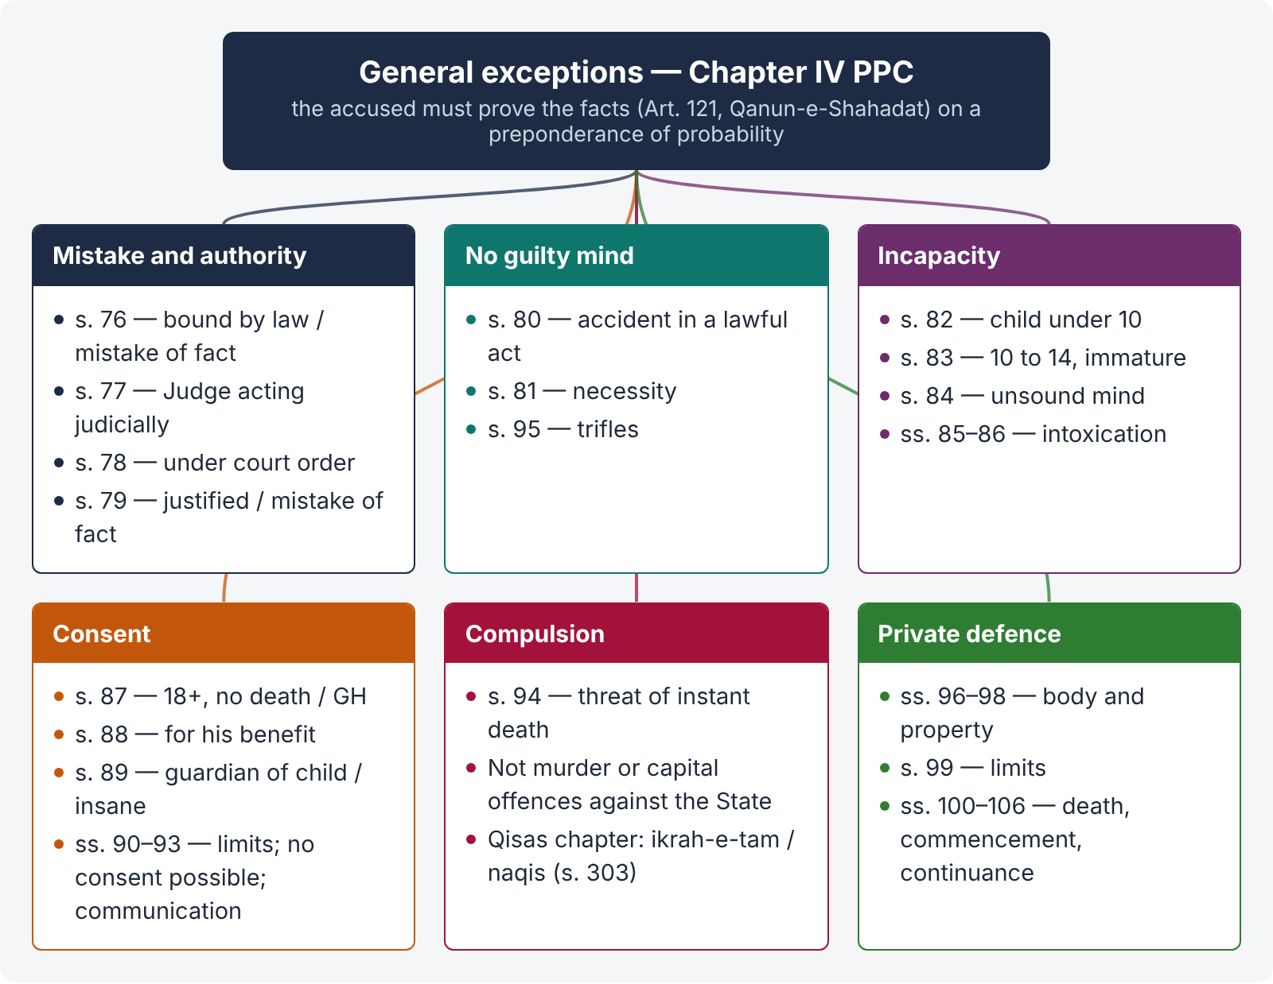
Figure 2 · The general exceptions at a glance

6.1 Burden of proof
The prosecution proves the offence; the accused who claims a general exception must prove the facts bringing his case within it (Art. 121, Qanun-e-Shahadat 1984), and the court shall presume the absence of such circumstances. The burden is lighter than the prosecution's — preponderance of probability; and even if the plea is not fully proved, evidence raising a reasonable doubt about an ingredient (e.g., intention) benefits the accused.

6.2 Excusable and justifiable acts
Excusable — no guilty mind | Mistake of fact (ss. 76, 79), accident (s. 80), infancy (ss. 82–83), insanity (s. 84), involuntary intoxication (s. 85)
Justifiable — the act is lawful | Judicial acts (s. 77), acts under court orders (s. 78), necessity (s. 81), consent (ss. 87–92), communication in good faith (s. 93), compulsion by threats (s. 94), trifles (s. 95), private defence (ss. 96–106)

6.3 Mistake of fact — ss. 76 and 79
LEGAL MAXIM · Ignorantia facti excusat; ignorantia juris non excusat
Ignorance of fact excuses; ignorance of law does not.

- s. 76 — a person who is, or by a mistake of fact (not law) in good faith believes himself to be, bound by law to do it. Illus.: a soldier fires on a mob by order of his officer in conformity with the law; an officer of court arrests Z believing him to be Y after due enquiry.
- s. 79 — a person justified by law, or who by mistake of fact in good faith believes himself justified. Illus.: A sees Z apparently committing murder and seizes him to take him to the authorities — though Z was in fact acting in self-defence.
- Difference: under s. 76 the person believes he is bound (must act); under s. 79 that he is justified (may act).
CASE STUDY · R v. Tolson (1889)
A woman remarried within seven years believing on reasonable grounds that her husband had drowned; he returned. Her conviction for bigamy was quashed — an honest and reasonable mistake of fact negatives mens rea.

6.4 Judicial acts — ss. 77, 78
A Judge acting judicially within a power which is, or which in good faith he believes to be, given by law (s. 77); and a person acting under a court's judgment or order while it is in force, even if the court lacked jurisdiction, provided he believes in good faith that it had (s. 78). See also the Judicial Officers Protection Act 1850.

6.5 Accident — s. 80
Nothing is an offence which is done (1) by accident or misfortune, (2) without criminal intention or knowledge, (3) in the doing of a lawful act, (4) in a lawful manner, by lawful means, and (5) with proper care and caution. Illus.: a hatchet-head flies off and kills a bystander. All five conditions are needed — firing in the air at a wedding is not a lawful act done with proper care.

6.6 Necessity — s. 81
An act done with knowledge that it is likely to cause harm, but without criminal intention and in good faith to prevent or avoid other harm to person or property. Whether the harm avoided was so serious and imminent as to justify the risk is a question of fact (Explanation). Illus.: a ship's captain changes course, risking a boat with two passengers to avoid running down a boat with thirty; pulling down houses to stop a great fire.
CASE STUDY · R v. Dudley and Stephens (1884)
Shipwrecked sailors killed and ate the cabin boy to survive. Necessity is no defence to murder — one cannot take an innocent life to save one's own. Section 81 is likewise limited by the requirement that there be no intention to cause harm.

6.7 Infancy — ss. 82, 83 (LHC 2023)
Age | Rule
Under 10 years (s. 82) | Absolute immunity — doli incapax: "Nothing is an offence which is done by a child under ten years of age." No trial is possible.
Above 10 and under 14 (s. 83) | Qualified immunity — no offence if the child "has not attained sufficient maturity of understanding to judge of the nature and consequences of his conduct on that occasion". Maturity is a question of fact (conduct before and after the act: concealment, flight, lying).
14 to under 18 | Fully responsible, but a juvenile: tried by a Juvenile Court under the Juvenile Justice System Act 2018; no death sentence; no handcuffs or fetters; diversion for minor offences (Topic 3).

Consequences of a criminal act by a child under ten: no offence at all — the child cannot be arrested, charged or tried; but the parent or guardian may be liable if he abetted or used the child as an innocent agent (s. 108, Explanation 3 — abetment of an act by a person incapable of committing an offence). The victim still has the right of private defence (s. 98). Under the Qisas chapter, a minor is not liable to qisas (ss. 306(a), 337M(a)) but is liable to diyat or arsh from his property or as the court directs (s. 308).

6.8 Insanity — s. 84 (KPHC 2026 essay)
"84. Nothing is an offence which is done by a person who, at the time of doing it, by reason of unsoundness of mind, is incapable of knowing the nature of the act, or that he is doing what is either wrong or contrary to law."

Origin — the M'Naghten Rules (1843)
Daniel M'Naghten, under a delusion of persecution, shot the secretary of the Prime Minister, Sir Robert Peel. His acquittal led the House of Lords to put questions to the judges, whose answers became the M'Naghten Rules: (1) every man is presumed sane; (2) to establish insanity it must be clearly proved that, at the time of the act, the accused was labouring under such a defect of reason, from disease of the mind, as not to know the nature and quality of the act, or, if he did know it, that he did not know it was wrong. Section 84 codifies these rules.

Ingredients
- Unsoundness of mind (any mental disease — schizophrenia, severe psychosis, idiocy, epilepsy in a fit);
- existing at the time of the act — not before or after only;
- which makes the accused incapable of knowing (a) the nature of the act (he thinks he is cutting a melon when he cuts a throat), or (b) that it is wrong or contrary to law (he believes God has ordered the killing).

Legal insanity vs medical insanity
The test is legal, not medical. Not every mental illness is insanity under s. 84. Medical insanity (a diagnosed disorder) is not enough unless it destroyed the cognitive faculty — the capacity to know the nature or wrongness of the act. Irresistible impulse, emotional disturbance, eccentricity, fits of anger or jealousy are not legal insanity.

Proof
- Presumption of sanity; burden on the accused (Art. 121, QSO), on a preponderance of probability.
- The court looks at circumstances before, at and after the act: motive; preparation; manner of commission; conduct afterwards (did he hide the weapon, flee, give a rational explanation?); medical history (previous treatment, hospital records); evidence of family and neighbours; medical board opinion.
- Absence of motive, the bizarre manner of killing, and the accused's staying at the spot are relevant but not conclusive.
- Even where the plea is not proved, evidence of mental illness that creates reasonable doubt about intention, or is a mitigating circumstance, affects the sentence.

Procedure under the CrPC
- Inquiry into unsoundness at trial — if the accused appears to be of unsound mind and incapable of making his defence, the court tries that fact (with medical evidence) and, if found so, postpones the trial (CrPC ss. 464–465); the accused may be released on security or detained (s. 466); the trial resumes when he becomes fit (s. 467).
- Acquittal on the ground of insanity — the finding must state whether he committed the act (s. 470); he is then kept in safe custody and reported to Government (s. 471).
- Insanity after conviction — a mentally ill convict cannot be executed if he cannot understand the punishment and its reason.
CASE STUDY · Safia Bano v. Home Department, Government of Punjab (PLD 2021 SC 488)
A larger bench of the Supreme Court held that a condemned prisoner who, because of severe mental illness, cannot comprehend the rationale and reason for his punishment shall not be executed; the sentence may be commuted. It recognised mental illness as a mitigating factor and directed the creation of medical boards and training for judges, prosecutors and police on mental-health issues (decided together with the connected cases of Kanizan Bibi and Imdad Ali).

EXAM TIP · Essay plan (insanity)
Introduction (presumption of sanity; actus non facit reum) → s. 84 text → M'Naghten → ingredients → legal vs medical insanity → burden and standard (Art. 121) → evidence the courts look at → CrPC ss. 464–475 → Safia Bano (post-conviction insanity) → critique (no "diminished responsibility" in Pakistan; need for forensic psychiatry) → conclusion.

6.9 Intoxication — ss. 85, 86
- Involuntary intoxication (s. 85) — nothing is an offence by a person who, by reason of intoxication, is incapable of knowing the nature of the act or that it is wrong or contrary to law, provided the intoxicant was administered without his knowledge or against his will.
- Voluntary intoxication (s. 86) — no defence: where an offence requires a particular knowledge or intent, the voluntarily intoxicated person is treated as having the same knowledge as if sober. (Courts may still consider whether, in fact, he could form the intention.) In Pakistan voluntary drinking is itself an offence (Prohibition Order 1979, Topic 4).

6.10 Consent — ss. 87 to 92
s. 87 | An act not intended and not known likely to cause death or grievous hurt, done with the consent of a person above 18 (e.g., fair sport — fencing, boxing).
s. 88 | An act not intended to cause death, done in good faith for the benefit of a consenting person (e.g., a risky surgical operation).
s. 89 | An act done in good faith for the benefit of a child under 12 or an insane person by or with the consent of the guardian — but not intentional death, nor acts known likely to cause death except to prevent death or grievous hurt or cure grave disease.
s. 90 | Consent is not valid if given under fear of injury or misconception of fact (known to the doer), or by a person of unsound mind or intoxicated, or by a child under 12.
s. 91 | Exceptions in ss. 87–89 do not cover acts that are offences independently of harm to the consenting person (e.g., causing miscarriage, s. 338).
s. 92 | An act done in good faith for the benefit of a person without consent, where consent cannot be obtained in time (e.g., a surgeon operates on an unconscious accident victim).
s. 93 | A communication made in good faith for a person's benefit is no offence by reason of harm caused (a doctor tells a patient he has terminal cancer; the patient dies of shock).

6.11 Compulsion by threats — s. 94
Nothing is an offence (except murder (qatl) and offences against the State punishable with death) which is done by a person compelled by threats which reasonably cause apprehension of instant death to that person — provided he did not voluntarily place himself in that situation. Expl. 1: one who joins a gang of dacoits voluntarily has no defence. Expl. 2: a smith seized by dacoits and forced at the point of death to open a door is protected.
Ikrah-e-tam and ikrah-e-naqis (LHC 2023) — in the Qisas and Diyat chapter, duress has its own rules:
Point | Ikrah-e-tam (complete duress) — s. 299(g) | Ikrah-e-naqis (incomplete duress) — s. 299(h)
Meaning | Putting a person, his spouse or blood relation within the prohibited degrees in fear of instant death, instant permanent impairing of an organ, or instant fear of sodomy or zina-bil-jabr | Any other duress not amounting to ikrah-e-tam
Liability of the doer (s. 303) | Imprisonment 10 to 25 years | Punished for the kind of qatl he committed (full liability)
Liability of the person causing duress | Punished for the kind of qatl committed as a consequence (as principal) | Imprisonment up to 10 years

6.12 Trifles — s. 95
LEGAL MAXIM · De minimis non curat lex
The law does not concern itself with trifles. Nothing is an offence if the harm is so slight that no person of ordinary sense and temper would complain (e.g., taking a drop of ink from another's inkpot).

Chapter 7 · The right of private defence (ss. 96 to 106) — LHC 2020

7.1 Basis
The State cannot protect every citizen at every moment. The law therefore allows a person to defend himself and others, and property, until State help arrives. But the right is defensive, not punitive or retaliatory.
LEGAL MAXIM · Vim vi repellere licet
It is lawful to repel force by force — within limits.

7.2 Scope — ss. 96 to 98
- s. 96 — nothing done in the exercise of the right is an offence.
- s. 97 — every person may defend (i) his own body and the body of any other person against any offence affecting the human body; and (ii) property (movable or immovable) of himself or any other person against theft, robbery, mischief or criminal trespass, or attempts.
- s. 98 — the right exists even against a person who is not criminally liable — a child, an insane person, an intoxicated person, or one acting under misconception (illus.: a madman attacks A; A has the same right as against a sane man).

7.3 Restrictions — s. 99 (acts against which there is no right)
There is no right of private defence:
- against an act of a public servant acting in good faith under colour of his office, though not strictly justifiable by law, unless it reasonably causes apprehension of death or grievous hurt;
- against an act done by the direction of such a public servant, on the same condition;
- where there is time to have recourse to the protection of the public authorities;
- and the right in no case extends to inflicting more harm than is necessary for defence.
Explanations: a person loses the right against a public servant only if he knows or has reason to believe that the doer is a public servant (Expl. 1), or acting under his direction, or the authority is stated or produced in writing on demand (Expl. 2).

7.4 When the right of private defence of the body extends to causing death — s. 100
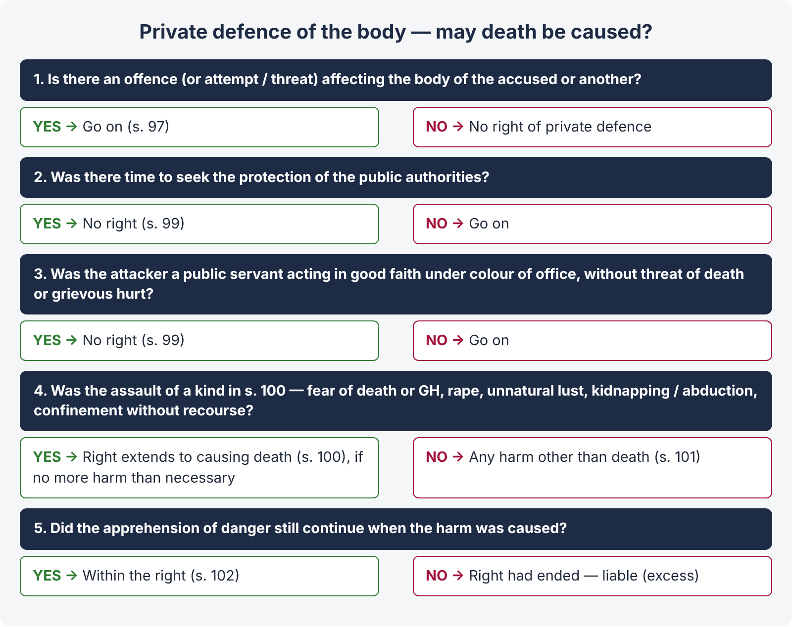
Figure 3 · Private defence — how far may I go?
The right extends to voluntarily causing death or any other harm to the assailant if the offence that occasions it is:
- an assault reasonably causing apprehension of death;
- an assault reasonably causing apprehension of grievous hurt;
- an assault with intention of committing rape;
- an assault with intention of gratifying unnatural lust;
- an assault with intention of kidnapping or abducting;
- an assault with intention of wrongfully confining a person in circumstances causing him to apprehend that he will be unable to have recourse to the public authorities for his release.
In all other cases the right of private defence of the body extends to causing any harm other than death (s. 101).

7.5 Commencement and continuance — body (s. 102)
The right of private defence of the body commences as soon as a reasonable apprehension of danger to the body arises from an attempt or threat to commit the offence, though the offence may not have been committed; and it continues as long as such apprehension of danger continues. There is no right to pursue and kill a fleeing assailant once the danger is over.

7.6 When the right of private defence of property extends to causing death — s. 103
Death may be caused to the wrong-doer if the offence (or attempt) is:
- robbery;
- house-breaking by night;
- mischief by fire on any building, tent or vessel used as a human dwelling or for the custody of property;
- theft, mischief or house-trespass in circumstances reasonably causing apprehension that death or grievous hurt will be the consequence if the right is not exercised.
For theft, mischief or criminal trespass not of these kinds, the right extends to any harm other than death (s. 104).

7.7 Commencement and continuance — property (s. 105)
Commences | When a reasonable apprehension of danger to the property commences
Against theft | Continues till the offender has effected his retreat with the property, or the assistance of the public authorities is obtained, or the property has been recovered
Against robbery | As long as the offender causes or attempts to cause death, hurt or wrongful restraint, or as long as the fear of instant death, hurt or personal restraint continues
Against criminal trespass or mischief | As long as the offender continues in the commission of the trespass or mischief
Against house-breaking by night | As long as the house-trespass begun by the house-breaking continues

7.8 Risk to an innocent person — s. 106
If, in defending against an assault reasonably causing apprehension of death, the defender cannot effectually exercise the right without risk of harm to an innocent person, his right extends to running that risk (illus.: A, attacked by a murderous mob, fires and harms children mingled with it — no offence).

7.9 Principles from the case law
- The plea must ordinarily be taken at the earliest stage (in the s. 342 CrPC statement) and the accused must show the facts; but the court may find it from the prosecution evidence itself.
- The accused's injuries and their non-explanation by the prosecution may support the plea.
- The harm caused must be proportionate, but the defender is not expected to weigh it in golden scales in the heat of the moment.
- Free fight — where both sides come prepared and fight, neither has a right of private defence; each is liable for his own acts.
- Exceeding the right — where the right existed but was exceeded, the accused is liable for the excess; under the Qisas scheme the court may treat it as a case where qisas is not applicable and award ta'zir under s. 302(c) (punishment up to 25 years).

Chapter 8 · Abetment (ss. 107 to 120) — KPHC 2026

8.1 Abetment of a thing — s. 107
A person abets the doing of a thing who —
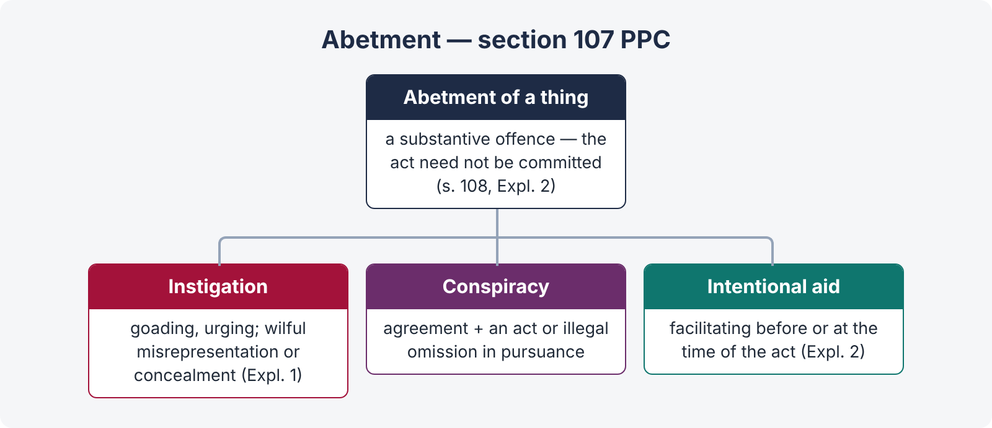
Figure 4 · The three forms of abetment
- Instigates any person to do that thing — to goad, urge, encourage, provoke, by words or conduct, or by wilful misrepresentation or concealment of a material fact he is bound to disclose (Expl. 1);
- Engages in a conspiracy with one or more persons for doing that thing, if an act or illegal omission takes place in pursuance of the conspiracy and in order to the doing of that thing; or
- Intentionally aids, by any act or illegal omission, the doing of that thing — doing anything prior to or at the time of the act to facilitate it (Expl. 2).

8.2 Abettor — s. 108
A person abets an offence who abets either the commission of an offence, or of an act which would be an offence if committed by a person capable by law of committing it with the abettor's intention or knowledge. Explanations:
- Abetment of an illegal omission may be an offence though the abettor is not bound to do the act (Expl. 1).
- It is not necessary that the act abetted be committed, or the effect be caused (Expl. 2) — abetment is a substantive offence.
- The person abetted need not be capable of committing an offence, nor have the same guilty intention (Expl. 3) — e.g., using a child under ten as an innocent agent.
- Abetment of an abetment is an offence (Expl. 4).
- In abetment by conspiracy, the abettor need not concert with the person who commits the offence; it is enough that he engaged in the conspiracy (Expl. 5).
s. 108A — abetment in Pakistan of an offence outside Pakistan which would be an offence if committed here.

8.3 Punishment of abetment — the scheme
s. 109 | If the act abetted is committed in consequence of the abetment and there is no express provision — the abettor gets the punishment provided for the offence.
s. 110 | If the person abetted acts with a different intention — the abettor is punished as if the act had been done with his (the abettor's) intention.
s. 111 | If one act is abetted and a different act is done — the abettor is liable for the act done as if he had directly abetted it, provided it was a probable consequence of the abetment and done under its influence (illus.: A instigates a child to poison Z's food; the child poisons Y's food instead — A is liable).
s. 112 | Abettor liable to cumulative punishment for the act abetted and the act done.
s. 113 | Liable for an effect different from that intended, if he knew it likely.
s. 114 | If the abettor is present when the offence is committed, he is deemed to have committed it (principal).
s. 115 | Abetment of an offence punishable with death or imprisonment for life, if the offence is not committed in consequence — imprisonment up to 7 years and fine; if an act causing hurt is done in consequence — up to 14 years and fine.
s. 116 | Abetment of an offence punishable with imprisonment, if the offence is not committed — up to one-fourth of the longest term; if the abettor or the person abetted is a public servant whose duty is to prevent the offence — up to one-half.
s. 117 | Abetting an offence by the public or by more than ten persons — up to 3 years.
ss. 118–120 | Concealing a design to commit an offence: punishable with death or life — 7 years if committed, 3 years if not (s. 118); by a public servant whose duty it is to prevent — half (s. 119); punishable with imprisonment — one-fourth / one-eighth (s. 120).

ILLUSTRATION · Illustrations to remember
- s. 115: A instigates B to murder Z. B does not do it. A — up to 7 years. If B injures Z — up to 14 years.
- s. 116: A offers a bribe to B, a public servant; B refuses — A is guilty of abetment (illus. (a)). A police officer whose duty is to prevent robbery abets a robbery that is not committed — half the longest term (illus. (c)).
- s. 114: A instigates B to kill Z and stands by holding Z's arms while B stabs him — A is a principal.

8.4 Abetment and common intention
Point | Abetment (s. 107) | Common intention (s. 34)
Nature | A substantive offence | A rule of joint liability
Presence | Abettor need not be present (if present — s. 114) | Participation, usually presence, required
Commission of the act | Not necessary (Expl. 2 to s. 108) | The criminal act must be done

Chapter 9 · Criminal conspiracy (ss. 120A, 120B)

9.1 Definition — s. 120A
"When two or more persons agree to do, or cause to be done, (1) an illegal act, or (2) an act which is not illegal by illegal means, such an agreement is designated a criminal conspiracy: Provided that no agreement except an agreement to commit an offence shall amount to a criminal conspiracy unless some act besides the agreement is done by one or more parties in pursuance thereof." Explanation: it is immaterial whether the illegal act is the ultimate object or merely incidental.
Gist: the agreement itself. For an agreement to commit an offence, no overt act is needed; for other illegal acts (e.g., a civil wrong), an overt act is required.

9.2 Punishment — s. 120B
- Conspiracy to commit an offence punishable with death, imprisonment for life or rigorous imprisonment for 2 years or more — punished as an abettor of that offence, where no express provision exists.
- Any other conspiracy — up to six months, or fine, or both.

9.3 Conspiracy and abetment by conspiracy
Point | Criminal conspiracy (s. 120A) | Abetment by conspiracy (s. 107, secondly)
Gist | The agreement | Agreement plus an act or illegal omission in pursuance
Overt act | Not needed for an agreement to commit an offence | Always needed
Nature | Independent offence | A form of abetment

Proof is usually by circumstantial evidence; acts and statements of one conspirator in furtherance of the common design are relevant against all (Art. 23, Qanun-e-Shahadat).

Chapter 10 · Attempt (s. 511)

10.1 The section
"Whoever attempts to commit an offence punishable by this Code with imprisonment for life or imprisonment, or to cause such an offence to be committed, and in such attempt does any act towards the commission of the offence, shall, where no express provision is made by this Code for the punishment of such attempt, be punished with imprisonment … for a term which may extend to one-half of the longest term provided for that offence, or with such fine [daman] as is provided for the offence, or with both."

10.2 Ingredients
- Intention to commit the offence;
- preparation; and
- an act towards the commission of the offence — going beyond preparation — which fails.
Illustrations: A breaks open a box to steal jewels and finds it empty — attempt to commit theft; A puts his hand into Z's empty pocket — attempt. Impossibility of the attempt (empty box, empty pocket) is no defence.

10.3 Tests to distinguish preparation from attempt
- Proximity test — the act must be sufficiently proximate to the intended crime.
- Locus poenitentiae — so long as the accused still has time to change his mind and draw back, it is preparation.
- Equivocality test — the act must unequivocally show the intent to commit the crime.
- Last-act test — the accused has done the last act within his power (too narrow).
Separate attempt sections: s. 324 (attempt to commit qatl-i-amd — up to 10 years and fine, plus punishment for any hurt caused), s. 393 (robbery), s. 398 (robbery or dacoity armed with a deadly weapon). Attempt to commit suicide was punishable under s. 325, which has been omitted (Act XXXVII of 2022) — it is no longer an offence.

Chapter 11 · Maxims and last-night revision

11.1 Maxims
Maxim | Meaning | Where it applies
Actus non facit reum nisi mens sit rea | No guilt without a guilty mind | Mens rea; strict-liability exceptions
Nullum crimen sine lege, nulla poena sine lege | No crime or punishment without law | Art. 12 of the Constitution — no retrospective punishment
Ignorantia juris non excusat | Ignorance of law is no excuse | ss. 76, 79 (mistake of law excluded)
Ignorantia facti excusat | Ignorance of fact excuses | ss. 76, 79
Doli incapax | Incapable of crime | s. 82 (under 10), s. 83 (10–14)
Furiosus nulla voluntas est | A madman has no will | s. 84
Vim vi repellere licet | Force may be repelled by force | ss. 96–106
De minimis non curat lex | The law ignores trifles | s. 95
Volenti non fit injuria | No injury to one who consents | ss. 87–88
Nemo debet bis vexari | No one shall be twice vexed | Art. 13 of the Constitution; CrPC s. 403

11.2 The 30 points of Topic 1
QUICK RECAP · Revision sheet
- Crime = actus reus + mens rea, coinciding; strict liability in public-welfare and narcotics offences.
- Stages: intention, preparation (punishable only in ss. 122, 126, 233–235, 257, 399, 402), attempt, commission.
- Code applies within Pakistan (s. 2) and to citizens abroad, persons in Pakistan's service, Pakistani ships and aircraft (s. 4); special laws saved (s. 5).
- Wrongful gain / loss (s. 23) — property; includes retaining and keeping out; dishonestly (s. 24) vs fraudulently (s. 25).
- Good faith (s. 52) — due care and attention, stricter than GCA s. 3(22).
- Harbour (s. 52A) — shelter, food, money, arms, conveyance, any help to evade arrest; spouse exception in ss. 130, 212, 216.
- s. 34 — common intention, prior meeting of minds, participation; rule of evidence (Mahbub Shah; Barendra Kumar Ghosh).
- s. 149 — five or more, common object, membership suffices; substantive offence.
- s. 53 — qisas, diyat, arsh, daman, ta'zir, death, life, imprisonment, forfeiture, fine.
- Life = 25 years (s. 57); qatl death sentence not commuted without heirs' consent (s. 54).
- Default imprisonment ≤ ¼ of maximum (s. 65); fine leviable within 6 years (s. 70).
- ss. 71–72 — one punishment for composite offences; lowest where doubtful.
- Solitary confinement ≤ 3 months (1/2/3 months scale), 14 days at a time, 7 days a month (ss. 73–74).
- s. 75 — previous conviction under Chapter XII or XVII, 3 years+, subsequent like offence → life or 10 years; not applicable to CNSA.
- General exceptions — burden on accused (Art. 121 QSO), preponderance of probability.
- Mistake of fact (ss. 76, 79), not law; bound vs justified.
- Accident (s. 80) — five conditions; necessity (s. 81) — no criminal intention; not for murder.
- Under 10 — no offence; 10–14 — maturity test (Act X of 2016); juveniles under JJSA 2018.
- Insanity (s. 84) — at the time, incapable of knowing nature or wrongness; legal not medical; M'Naghten; Safia Bano PLD 2021 SC 488.
- Intoxication — involuntary excuses (s. 85); voluntary does not (s. 86).
- Consent — ss. 87 (18+, not death or GH), 88 (benefit, not death intended), 89 (guardian, child under 12), 90 (invalid consent), 92 (no consent possible).
- Threats (s. 94) — instant death; not murder or capital offences against State; ikrah-e-tam vs ikrah-e-naqis (s. 303).
- Private defence — body of anyone; property against theft, robbery, mischief, criminal trespass (s. 97); against insane etc. (s. 98).
- No right (s. 99) — good-faith public servant (unless death / GH feared); time for public authorities; no excess.
- Death for body (s. 100) — death, GH, rape, unnatural lust, kidnapping / abduction, wrongful confinement without recourse.
- Death for property (s. 103) — robbery, house-breaking by night, arson of dwelling, theft / mischief / house-trespass with fear of death or GH.
- Commencement / continuance — body (s. 102), property (s. 105: theft until retreat / help / recovery…).
- Abetment — instigation, conspiracy + act, intentional aid (s. 107); need not be committed (s. 108 Expl. 2); s. 115 (7 / 14 years), s. 116 (¼ / ½).
- Conspiracy (s. 120A) — agreement; overt act only for non-offence objects; s. 120B punishment as abettor.
- Attempt (s. 511) — act beyond preparation; up to half the longest term; impossibility no defence; s. 324 for qatl.

